Week 3 Quiz

Graded Quiz • 10 min



**> head(iris)**

Sepal.Length Sepal.Width Petal.Length Petal.Width Species

1 5.1 3.5 1.4 0.2 setosa

2 4.9 3.0 1.4 0.2 setosa

3 4.7 3.2 1.3 0.2 setosa

4 4.6 3.1 1.5 0.2 setosa

5 5.0 3.6 1.4 0.2 setosa

6 5.4 3.9 1.7 0.4 setosa

**> names(iris)**

[1] "Sepal.Length" "Sepal.Width" "Petal.Length" "Petal.Width" "Species"

Want to find mean of column “Sepal.Length” and group by the species

tapply(X, INDEX, FUN = NULL, ..., default = NA, simplify = TRUE

|  |  |
| --- | --- |
| INDEX | a [list](http://127.0.0.1:19279/help/library/base/help/list) of one or more [factor](http://127.0.0.1:19279/help/library/base/help/factor)s, each of same length as X. The  elements are coerced to factors by [as.factor](http://127.0.0.1:19279/help/library/base/help/as.factor). |

**tapply(iris$Sepal.Length, iris$Species, mean)**

setosa versicolor virginica

5.006 5.936 6.588

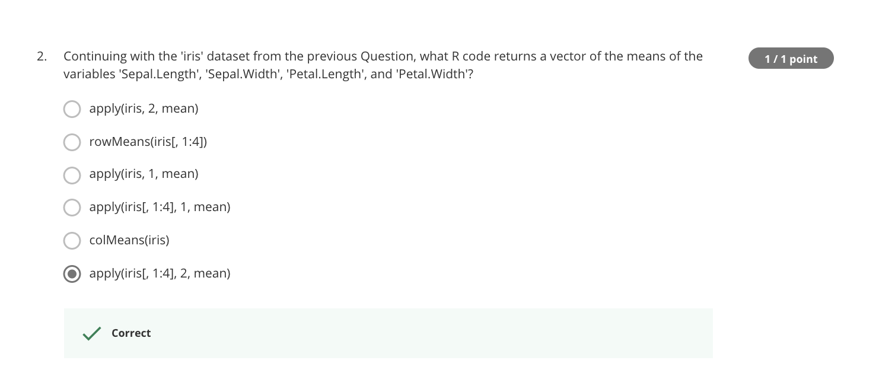

**apply(iris[, 1:4], 2, mean), where MARGIN=2 is col**

Sepal.Length Sepal.Width Petal.Length Petal.Width

5.843333 3.057333 3.758000 1.199333

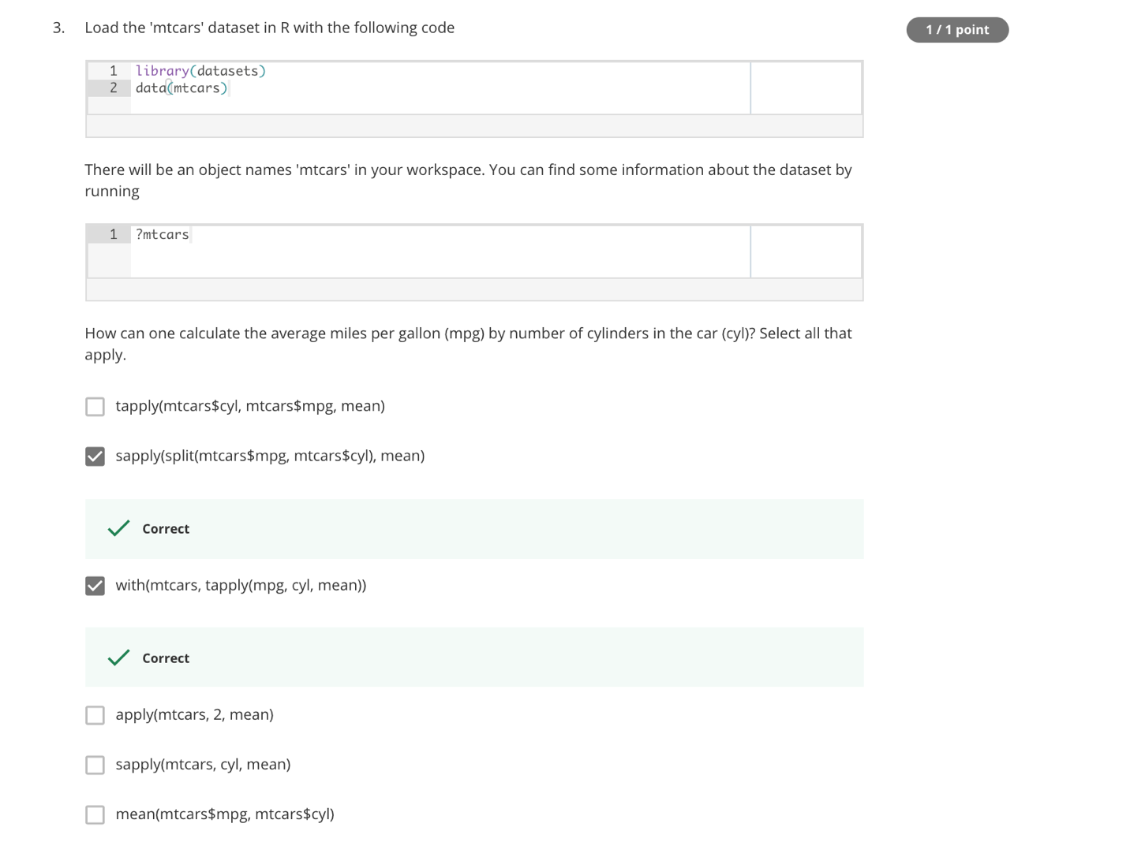

> library(dataset)

> data(mtcars)

> str(mtcars)

'data.frame': 32 obs. of 11 variables:

$ mpg : num 21 21 22.8 21.4 18.7 18.1 14.3 24.4 22.8 19.2 ...

$ cyl : num 6 6 4 6 8 6 8 4 4 6 ...

$ disp: num 160 160 108 258 360 ...

$ hp : num 110 110 93 110 175 105 245 62 95 123 ...

$ drat: num 3.9 3.9 3.85 3.08 3.15 2.76 3.21 3.69 3.92 3.92 ...

$ wt : num 2.62 2.88 2.32 3.21 3.44 ...

$ qsec: num 16.5 17 18.6 19.4 17 ...

$ vs : num 0 0 1 1 0 1 0 1 1 1 ...

$ am : num 1 1 1 0 0 0 0 0 0 0 ...

$ gear: num 4 4 4 3 3 3 3 4 4 4 ...

$ carb: num 4 4 1 1 2 1 4 2 2 4 ...

> head(mtcars)

mpg cyl disp hp drat wt qsec vs am gear carb

Mazda RX4 21.0 6 160 110 3.90 2.620 16.46 0 1 4 4

Mazda RX4 Wag 21.0 6 160 110 3.90 2.875 17.02 0 1 4 4

Datsun 710 22.8 4 108 93 3.85 2.320 18.61 1 1 4 1

Hornet 4 Drive 21.4 6 258 110 3.08 3.215 19.44 1 0 3 1

Hornet Sportabout 18.7 8 360 175 3.15 3.440 17.02 0 0 3 2

Valiant 18.1 6 225 105 2.76 3.460 20.22 1 0 3 1

